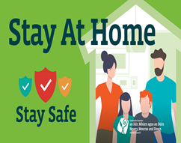

Free Health and Safety online class courses delivered into your living room

Classes will be delivered online by a tutor, candidates must have access to a laptop, or PC with a Webcam and Microphone with a maximum of 15 - 20 candidates depending on course. The classes are designed to assist volunteers and users of Community/Sports facilities throughout the district or for anyone who would like to gain new knowledge and skills to enhance their career prospects.

All courses are accredited, and candidates will receive a qualification or a certificate.

Courses delivered: by Health Matters Health and Safety

Requirements: Candidates must have access to a laptop, or PC with a Webcam and Microphone and must attend for the duration of the class.

Course details: A brief description is given on application form below.

Fire Risk Assessment awareness
Fire Warden Training
Essentials of First Aid
Safeguarding of Vulnerable Adults
Legionella Awareness

Registration: Pre Booking Essential
Register your interest by completing the application below indicating your class and dates you wish to attend, you can also include other members of your community by adding their E Mail address, your details will be used as the contact person.
E Mail your application to ccbookings@nmandd.org you will then be notified if successful, classes will be offered on a first come, first served basis. Class registration ends one week prior to class start date.

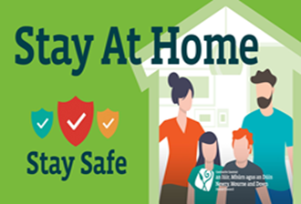

APPLICATION FORM
Name
Mobile/Phone
E Mail
Add E Mail
Add E Mail
Add E Mail
Add E Mail
Fire Risk Assessment awareness
This short course is for anyone who has to read, interpret and action any elements of a fire risk assessments. Please Tick
Tuesday | 23 March 2021 | 6.00pm – 9.00pm
Thursday | 25 March 2021 | 6.00pm – 9.00pm
Fire Warden Training
Health Matters have developed this training course to suit the needs of nominated staff who will assume the role and responsibility of being a Fire Warden within their respective department or work place.
Tuesday | 16 March 2021 | 6.00pm – 9.00pm
Thursday | 18 March 2021 | 6.00pm – 9.00pm
Essentials of First Aid
This is a short theory based First Aid course which aims to provide volunteers with the essential theory to assist them to act appropriately in the event of an emergency.
Tuesday | 9 March 2021 | 6.00pm – 9.00pm
Thursday | 11 March 2021 | 6.00pm – 9.00pm
Safeguarding of Vulnerable Adults
Make people aware and comply with the Northern Ireland Adult Safeguarding Partnership (NIASP) Training and Development Framework at Level 2 which covers awareness raising, recognising & responding.
Tuesday | 2 March 2021 | 6.00pm – 9.00pm
Thursday | 4 March 2021 | 6.00pm – 9.00pm
Legionella Awareness
This course would benefit anyone who volunteers within a community facility who would require a sound overview of the issues surrounding Legionella control, legislation and best practice procedures.
Tuesday | 23 February 2021 | 6.00pm – 9.00pm
Thursday | 25 February 2021 | 6.00pm – 9.00pm
E Mail completed application to ccbookings@nmandd.org stating online Health and Safety Courses
Courses are funded through DfC ‘Tranche 2 Covid-19 Community Support Fund’

